Domayne’s Extra Slim Cupboard

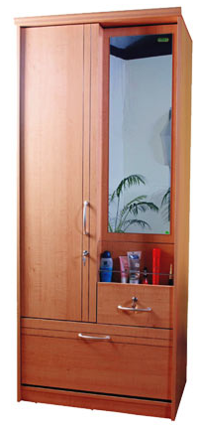

|  |
| --- |
| **DESCRIPTION** |
| Domayne’s dream designing has introduced an extra slim wooden cupboard with slim door and open mirror chest. The cupboard has a nice feel with smooth surface and a long chest for valuables. It gives you and your house a complete different look with its slim design it will fit easily in narrow and hard to reach places. |

|  |  |  |
| --- | --- | --- |
| **Price** | **650$** | |
| **Dimensions** | **H** x **W** x **L** | **75in x 22in x 27in** |
| **Features** | **The slim design enables us to move the cupboard and fit it to any place even in small bathrooms.** | |
| **Finished** | **Wooden gloss** | |
| **Available in** | **Brown and White** | |